**2.a. For the next quarter, your marketing department has a budget of $60,000 to spend on online campaigns. How would you allocate it between SMS and Email?**

**Answer:** The budget of $60,000 should be allocated as the following table:

|  |  |  |  |
| --- | --- | --- | --- |
| **Age Group** | **Budget per Age Group** | **SMS** | **Email** |
| 18-30 | 13,200 | 65% | 35% |
| 31-45 | 15,600 | 60% | 40% |
| 46-60 | 22,200 | 70% | 30% |
| 60+ | Reallocate the initial budget of 9,000 for the remaining age groups | | |

**Explain:**

Based on the potential customer pool size information of the next quarter => calculate the percentage of budget that should be analyzed additionally for each customer 

Because the business has just started a new product, the top priority is to maximize revenue, so here I will find ways to maximize revenue.

Below are the metrics calculated for each customer segment of interest:

- Cost per channel: **total_revenue**: revenue through channel, **cost_by_revenue**: % of cost in total revenue of each channel

- Reach per channel: **number_customer**: number of customers who sent information, **saw_review_rate**: % of customers who clicked to view the news, **bounced_rate**: percentage of customers who bounced

- Conversion per channel: **conversion_rate**: conversion rate

[**Link query by SQL BigQuery**](https://console.cloud.google.com/bigquery?sq=379086123169:62bee17586234974beb365a3b817a4cd)

**#Cost per channel**

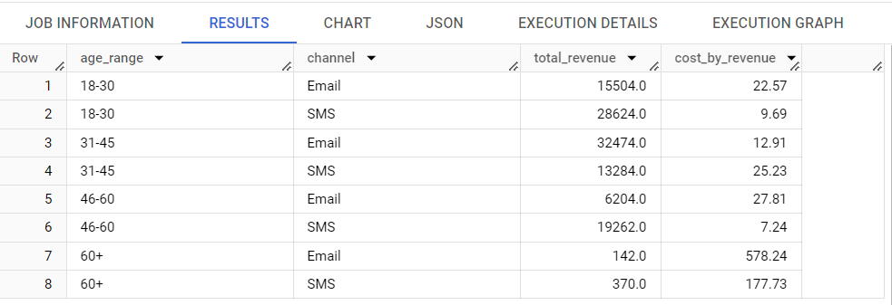

**#Reach per channel**

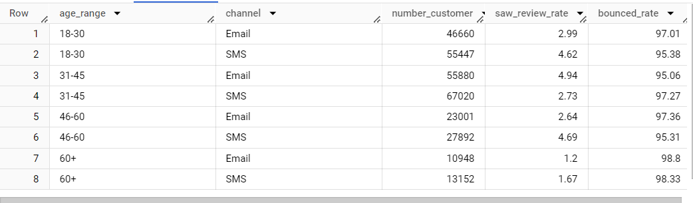

**#Conversison per channel**

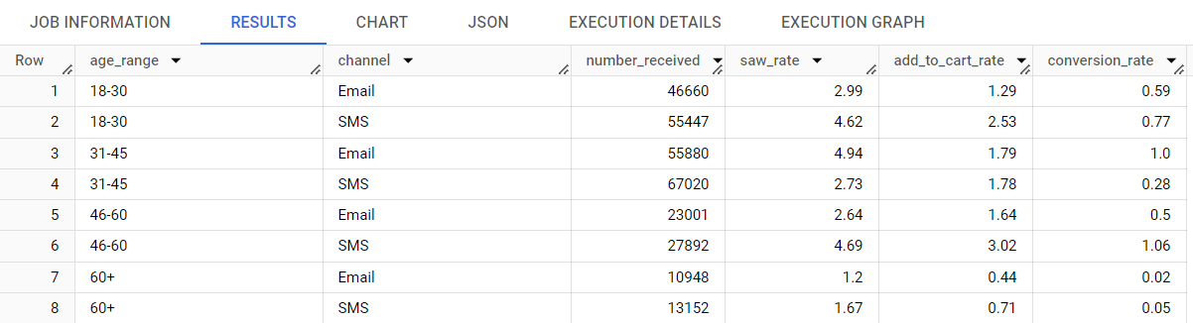

**### Age Group 18-30:**

- This is the youngest customer group and contributes significantly to the company's revenue.

- Revenue generated from the SMS channel accounts for 65% of the segment, and the cost of SMS is cheaper than Email.

- The SMS channel reaches 54% of customers, while Email reaches 46%. However, the SMS saw_review_rate is 4.6% higher.

- The add_to_cart and conversion rates for SMS are higher than for Email, indicating that higher marketing spending on SMS leads to more customers adding items to their cart, anticipating promotional events.

=> **Budget allocation:** SMS: 65% * 13,200 = 8,580, Email 35%: 4,620.

**### Age Group 31-45:**

- This customer group is one of the two largest revenue sources for the company.

- The Email channel generates 2.4 times more revenue than SMS, with marketing costs being half as much.

- The saw_review_rate for Email is nearly twice that of SMS, though the number of customers reached is lower.

- Conversely, the add_to_cart rate for SMS is higher after customers click to view a product.

- The conversion rate for Email is three times that of SMS.

=> **Budget allocation:** Email: 60% * 15,600 = 9,360, SMS 40%: 6,240.

**### Age Group 46-60:**

- This is the most promising customer segment for the company, though current revenue from this group is below expectations.

- The SMS channel holds a near-absolute advantage, generating three times the revenue of Email at a lower cost. Additionally, the add_to_cart and conversion rates for SMS are double those of Email.

=> **Budget allocation:** SMS: 70% * 22,200 = 15,540, Email 30%: 6,660.

**### Age Group 60+:**

- This is the least promising customer segment for the company, with costs almost always exceeding revenue.

- Moreover, the conversion rate is extremely low, at just 0.05%.

=> Reallocate the initial budget of 9,000 evenly among the remaining customer segments.

**2.b. Now assume that you are also responsible for the operation of the company’s website. Do you have any comments or suggestions so that we can improve the website’s performance in order to maximize net profit?**

I can’t reach the website because the web has some problem. However, according to the results from the question a and some information I collect in the Google. There are some my suggestion:

**1. Improve the Website's User Experience** A user-friendly website is crucial for retaining visitors and converting them into customers. The site should be easy to navigate with intuitive layout and clear calls to action. According to Jakob Nielsen, a renowned web usability consultant, "A well-designed user interface significantly boosts user satisfaction and engagement." Additionally, the website must be visually appealing and optimized for mobile devices, as Google reports that 61% of users are unlikely to return to a mobile site they had trouble accessing.

**2. Optimize the Website for Search Engines** Search engine optimization (SEO) is essential for increasing the website's visibility. By implementing effective SEO strategies, potential customers can easily find the website when searching for relevant keywords. Moz, a leading SEO software provider, emphasizes that "Good SEO work only gets better over time. It’s only search engine tricks that need to keep changing when the ranking algorithms change."

**3. Use Retargeting to Reach Previous Visitors** Retargeting, a powerful advertising technique, enables businesses to show ads to users who have previously visited their website. This method is particularly effective in converting visitors who have abandoned their carts or are still contemplating a purchase. According to AdRoll, a prominent retargeting platform, "Retargeting ads are 76% more likely to get clicks compared to regular display ads."

**4. Offer Incentives to Encourage Purchases** Providing incentives such as discounts, coupons, and free shipping can significantly boost conversion rates. Dr. Robert Cialdini, an expert in the psychology of persuasion, highlights that "Offering limited-time promotions creates a sense of urgency, prompting customers to act quickly to take advantage of the deal."

**5. Utilize Social Media Marketing to Engage Potential Customers** Social media platforms offer an excellent opportunity to connect with potential customers and promote the website. Businesses can share engaging content, run contests, and provide customer support through these channels. According to HubSpot, a leader in inbound marketing, "Social media has a 100% higher lead-to-close rate than outbound marketing, underscoring its effectiveness in driving sales."

Implementing these strategies, backed by expert insights, can significantly enhance digital marketing efforts, leading to improved user experience, higher visibility, and increased conversions.